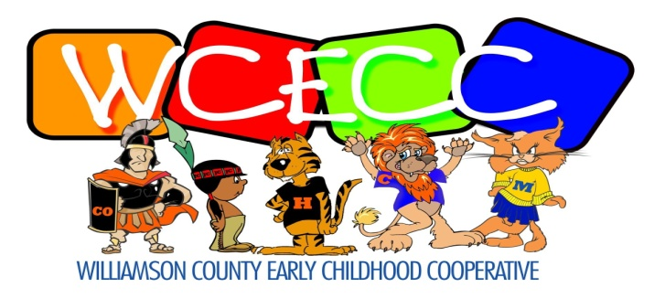

618-993-2138 411 S. Court Street 618-997-3950

Phone Marion, IL 62959 FAX

*Jami Hodge, Director* *Jaci Crain, Coordinator*

______________________________________________________________________________

PUBLIC NOTICE OF MEETING

The Executive Committee of Williamson County Early Childhood Cooperative will hold a regular quarterly meeting on Thursday, July 11, 2024, at 8:30 a.m., WCES, 411 S. Court Street, Marion, IL 62959